**Kailas gold sponsor of TORX® and main sponsor of Gran Trail Courmayeur  
  
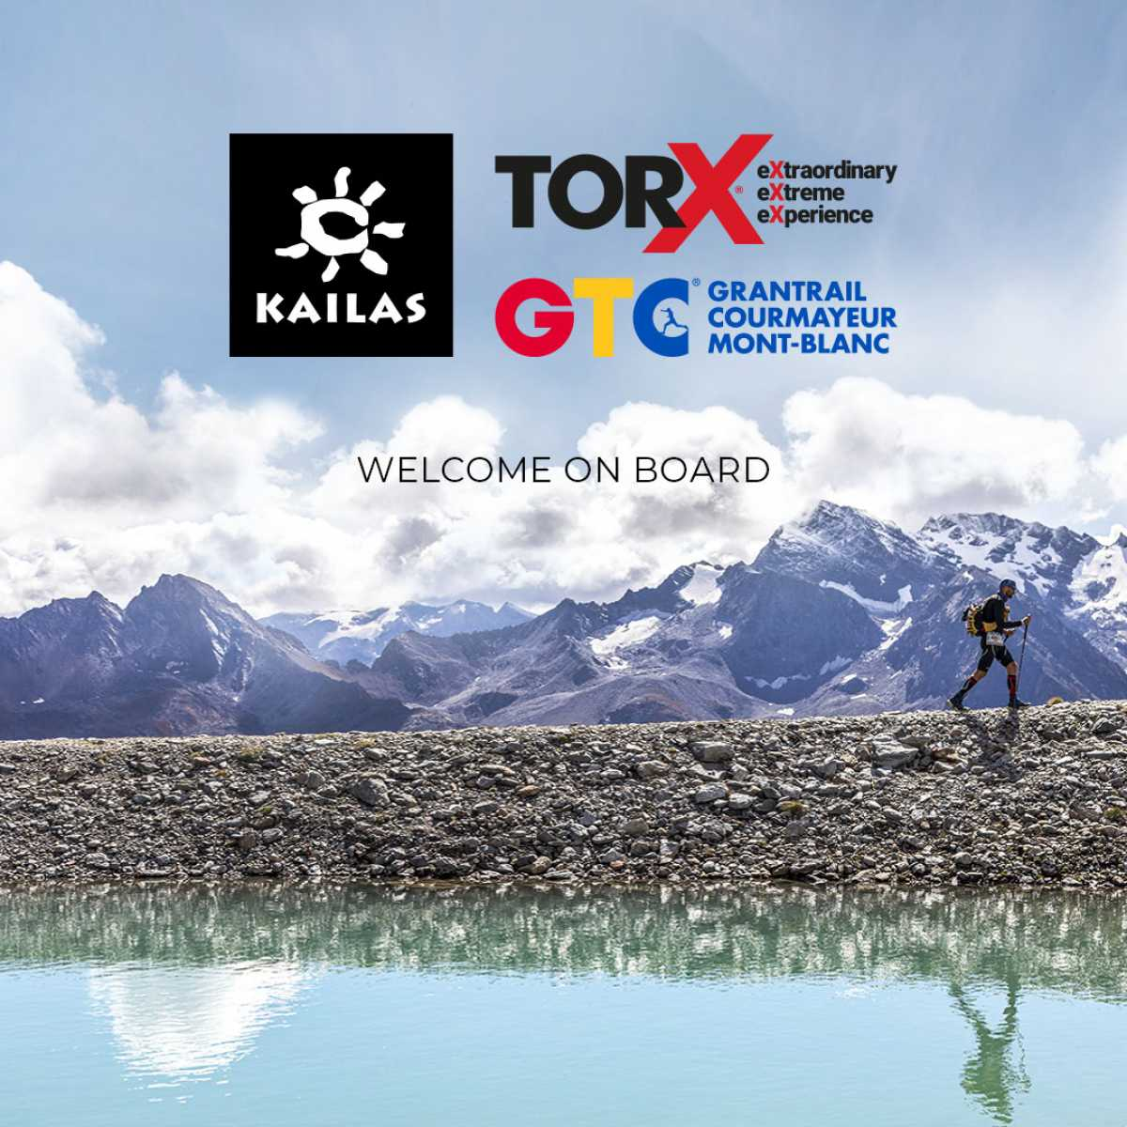**

| ***Kailas welcome on board -*** [***DOWNLOAD HERE***](https://torxtrail.com/it/file/13452/download?token=Alr_xp3R&utm_source=sendinblue&utm_campaign=CS%2009%20-%202022%20ENG%20%20Kailas%20gold%20sponsor%20of%20TORX%20%20and%20main%20sponsor%20of%20Gran%20Trail%20Courmayeur&utm_medium=email) |
| --- |

*Monday, 11th April 2022 -*  **Kailas** joins the [**TORX® eXperience**](https://torxtrail.com/en/content/torx%C2%AE-experience?utm_source=sendinblue&utm_campaign=CS%2009%20-%202022%20ENG%20%20Kailas%20gold%20sponsor%20of%20TORX%20%20and%20main%20sponsor%20of%20Gran%20Trail%20Courmayeur&utm_medium=email). The sports equipment sector leader in China will be the gold sponsor in 2022 for all the races in the circuit - **TOR450 – Tor des Glaciers, TOR330 - Tor des Géants®, TOR130 - Tot Dret and TOR30 - Passage au Malatrà**, and main sponsor of the **Gran Trail Courmayeur**.

Established in 2003, the name [**Kailas**](https://kailasgear.com/?utm_source=sendinblue&utm_campaign=CS%2009%20-%202022%20ENG%20%20Kailas%20gold%20sponsor%20of%20TORX%20%20and%20main%20sponsor%20of%20Gran%20Trail%20Courmayeur&utm_medium=email)comes from the name of the holy Tibetan mountain **Kailash**, a sacred destination of religious pilgrimage. Every year religious pilgrims make the journey to Mount Kailash, following the traditions of their ancestors. The rugged terrain, high altitude and harsh climate all contribute to the difficulties of the pilgrimage, but those who choose to take it on remain undeterred. It is an undertaking that expresses the search for freedom, which is the philosophy that Kailas lives by and at the same time one of the founding values of **TORX®**. It was inevitable, then, that the paths of these two enterprises would cross.

Kailas has a strong presence in China with **over 350 directly-owned stores and 650 franchise stores**. The company has also achieved greater visibility around the world through retail outlets in countries such as Canada, Switzerland, Spain, Greece, Japan, Singapore, Malaysia, Nepal, Thailand, Vietnam, Russia, Iran, Kazakhstan and more. With its innovative equipment and approach, Kailas products are winners of the **ISPO Award, the Europe Outdoor Industry Award and the Asia Outdoor Industry Award**. Kailas shares its passion for outdoor living with climbing communities by proudly collaborating with **IFSC, the Tokyo Mountaineering Federation, Sport Climbing Australia, the Chinese Mountaineering Association and the Chinese Climbing Team**.

Since it was founded, **Kailas** has launched a series of programmes to promote mountaineering and climbing throughout China, with events such as the **Yangshuo Climbing Festival, Unclimbed Peak, Rock Searching and the Ice Climbing Festival**.

Kailas has extended its product line to include trail running and is committed to promoting trail running throughout China, sponsoring a large number of qualifying races such as **HK100, Ultra Tour Mt Siguniang and Mogan Ultra**, to which the **TORX®** and **Gran Trail Courmayeur** races will be added this year. Kailas currently sponsors over 400 national and international trail running events.

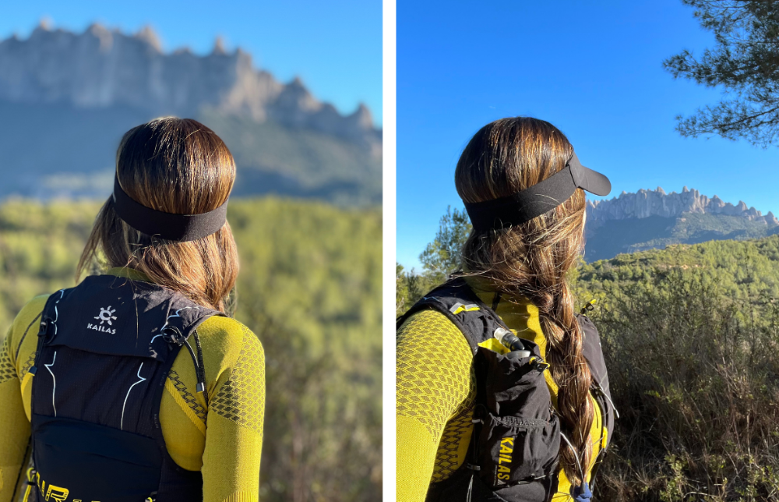



| | **TORX® eXperience** is a new circuit of competitions united by the TORX® values and experience, with breath-taking views as the reward for all the effort, passion, sharing and connection that provide such enduring memories. And **TORX®** has now created a new concept: PAX- race numbers reserved exclusively for those who finish a [TORX® eXperience](https://torxtrail.com/en/content/torx%C2%AE-experience?utm_source=sendinblue&utm_campaign=CS%2008%20-%202022%20ENG%20%20TORX%20charity%20and%20environmental%20numbers%20now%20on%20sale%20parts%20of%20the%20proceeds%20go%20to%20the%20-Valle%20dAosta%20for%20Ukraine-%20fund&utm_medium=email) race. If you're a finisher you're in Heaven's waiting room with a race number for the **TOR330 - Tor des Géants®**. With the new PAX system you’re a step nearer to the ultimate challenge - running in the legendary Tor des Géants® the following year without going through the draw.  A limited number of PAXs for the TOR 330 will be available each year, reserved exclusively for those who finish a TORX® eXperience. This year **200 PAXs** will be available for finishers of the **TOR130 – Tot Dret** and **100 PAXs** for finishers of the GTC100, regardless of their position in the rankings.  As usual, registrations must be done online at [100x100trail.com](http://www.100x100trail.com/?utm_source=sendinblue&utm_campaign=CS%2008%20-%202022%20ENG%20%20TORX%20charity%20and%20environmental%20numbers%20now%20on%20sale%20parts%20of%20the%20proceeds%20go%20to%20the%20-Valle%20dAosta%20for%20Ukraine-%20fund&utm_medium=email). Regulations and further information are available on the **TORX®** website. | | --- | |
| --- | --- |

**PRESS OFFICE TORX®**

**Erica Motta - Head of Communication**

M + 39 347 1342003

e.motta@vdatrailers.it

**Massimiliano Riccio - PiùPress**

M +39 347 9179915

press@vdatrailers.it