**TORX® is about to take off in China**

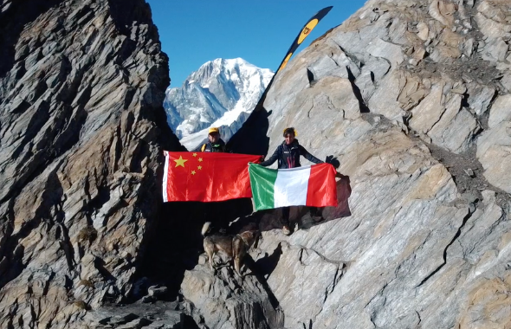

| **TORX® staff in Col du Malatrà -**  [***DOWNLOAD HERE***](https://torxtrail.com/sites/default/files/styles/gallery_top_banner/public/TORX%20CHINA%20Col%20du%20Malatra%CC%80.png?itok=KtMA7xhF&utm_source=sendinblue&utm_campaign=CS%2004-2022%20ENG%20%20Il%20TORX%20%20pronto%20a%20volare%20in%20Cina&utm_medium=email) |
| --- |

*Thursday, 10th February 2022 -*  **TORX®** journey doesn't end in September with the last runner who crosses the finish line in **Courmayeur,** it keeps going, flying across borders to new destinations, getting bigger and even more exciting. **VDA Trailers**, the organisers of **TORX®**, have recently signed an agreement with the **LetourSports** company to bring the event to **China**.

LetourSports is a satellite company of the **Kailas Group**, another well-known international outdoor brand which organises sporting events such as cycling, climbing, canyoning, marathon and trail running. In the trail-running sector in particular, the events organised by LetourSports in recent years include the **Guang Zhou Ultra Race 100, the Mogan UltraKailas, the Bejing 100 Ultra and the Mount Tai 100**.

This new five-year project means the TORX brand will be used for a series of competitions **between 2022 and 2027**, all having the same basic features as the original race: names and lengths of the races, number of runners, logistical organisation and uniqueness of the chosen location (involving an iconic passage similar to the **Col du Malatrà**), and including the eco-sustainability and fair-play elements of the competition.

“We've been developing the idea of expanding outside Italy for a couple of years," explains **Alessandra Nicoletti** - President of **VDA Trailers**, "but of course the pandemic turned everything upside down for a while. The TORX® is a closed competition with a restricted number of runners, so we decided to set up other **TORX®** races around the world for two reasons: to provide opportunities to experience the **TORX®** for those who can't afford to travel, and to broaden the range of runners who might be interested in coming to the Valle d'Aosta by offering a chance to take part in the original race. We're starting with China, a place we've had close contact with for years, which has facilitated the introduction of a new race based on the original. We believe the oriental market is very promising. The long-term goal is to export the model to other areas of the world too, from America to New Zealand”.

The selected location is the **Yunnan-Guizhou plateau** in Southwest China, and the race will take place in summer 2022, health conditions permitting. The Guizhou region is one of the **New York Times**' fifty best places in the world to visit (2016 list). **Courmayeur** [made into the list this year too](https://www.nytimes.com/interactive/2022/travel/52-places-travel-2022.html?utm_source=sendinblue&utm_campaign=CS%2004-2022%20ENG%20%20Il%20TORX%20%20pronto%20a%20volare%20in%20Cina&utm_medium=email).

"We are honoured and delighted to support the **TORX®** journey in the East," says **Yang Long**, CEO of LetourSports, "committed to representing a new base in Asia and dedicated to creating a new, extraordinary, extreme experience which embodies the fundamental characteristics of the TORX®. By developing events in Asia, we hope to provide the best Chinese runners with the opportunity to participate in the **TORX®** in Italy.”

Under the agreement, the new competition forms part of the [**TORX®** **eXperience**](https://torxtrail.com/it/content/torx%C2%AE-experience?utm_source=sendinblue&utm_campaign=CS%2004-2022%20ENG%20%20Il%20TORX%20%20pronto%20a%20volare%20in%20Cina&utm_medium=email)circuit, which means finishers of the Chinese TORX® - final number to be determined - are entitled to **PAX** numbers and eligible to register for the Valle d’Aosta race without going through the draw. The number of **PAX** numbers is set to increase in the coming months to create a world-class [**TORX® eXperience**](https://torxtrail.com/it/content/torx%C2%AE-experience?utm_source=sendinblue&utm_campaign=CS%2004-2022%20ENG%20%20Il%20TORX%20%20pronto%20a%20volare%20in%20Cina&utm_medium=email) by incorporating new races with the same unique features as the existing ones in the circuit - international prestige, high levels of competition and organisation, and high levels of difficulty to test the runners.

Look at the video [**here**](https://youtu.be/WHkYRKwkPps?utm_source=sendinblue&utm_campaign=CS%2004-2022%20ENG%20%20Il%20TORX%20%20pronto%20a%20volare%20in%20Cina&utm_medium=email)



Prre-registrations for the **TOR330 - Tor des Géants® -** are open until midnight on **14 February**. The lucky entrants will be drawn by the end of the month, and will then have time between 1 and 31 March to complete their registrations.

As usual, registrations must be done online at [100x100trail.com](http://www.100x100trail.com/?utm_source=sendinblue&utm_campaign=CS%2004-2022%20ENG%20%20Il%20TORX%20%20pronto%20a%20volare%20in%20Cina&utm_medium=email). Regulations and further information are available on the **TORX®** website.

**PRESS OFFICE TORX®**

**Erica Motta - Head of Communication**

M + 39 347 1342003

e.motta@vdatrailers.it

**Massimiliano Riccio - PiùPress**

M +39 347 9179915

press@vdatrailers.it