**TORX® 2022 POSTER UNVEILED**

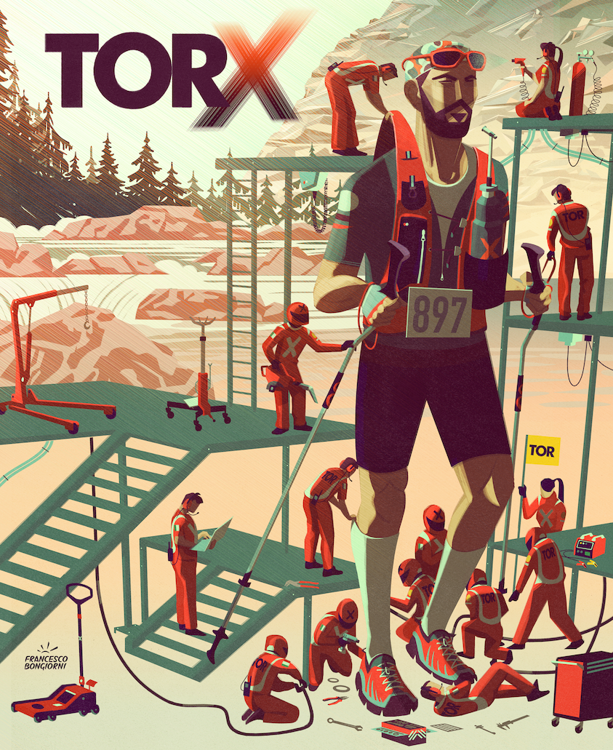

| **OFFICIAL TORX® 2022 POSTER - Illustration by Francesco Bongiorni -**  [***DOWNLOAD HERE***](https://we.tl/t-qwZ6wneaL7?utm_source=sendinblue&utm_campaign=CS%2003-2022%20ENG%20%20Svelato%20il%20manifesto%20del%20TORX%202022&utm_medium=email) |
| --- |

*Tuesday, 1st February 2022 -*  **The TORX®** is like a clock, made up of a series of complex gears: athletes, volunteers, trail builders, organizers, the public and the media. In the same way, this car so well structured and tested today recalls the mechanisms of **Formula One,** with that extreme attention to every single detail.

The idea behind the **TORX® 2022 poster**, unveiled this morning during a live streaming on the race's social channels, came from this reflection by the illustrator **Francesco Bongiorni**.

"If last year the concept was all about the freedom regained - explains Bongiorni who had already signed the image of 2021 - for this edition I imagined mechanics setting up an athlete ready to go. At the same time, it's an allegory for the people, technical and prepared, who finalize the last fundamental elements for the race to take place. I wanted to leave shadows and colors that give the moment a suspension and a certain solemnity, in order to make the moment electric and adrenaline-pumping".

The collaboration between **VDA Trailers** and **Bongiorni** is therefore renewed, thanks to the sharing of the values ​​that feed **TORX®** and to the deep knowledge of the Aosta Valley, to which Francesco has been linked since childhood

The **TORX® 2021** poster was selected for the exhibition of the prestigious **New York Society of Illustrators** award and is currently on display in Manhattan.

**Francesco Bongiorni**

Born in Milan in 1984, **Francesco Bongiorni** creates impactful and conceptual images, interpreting and synthesizing complex ideas in an original way. Francesco produces strong and sophisticated illustrations, conveying a clear and direct message to the viewer. He speaks and works in three languages (Italian, English and Spanish) and splits his time between Milan and Madrid. His style is synthetic and direct, the result of his heterogeneous formation that includes Engraving studies, screen printing, comics and painting at the Academy of Fine Arts N.A.B.A. of Milan, the Universidad de Bellas Artes of Salamanca and the IED of Milan. Francesco collaborates regularly with: The New York Times, AC Milan, Air France, The Guardian, Washington Post, The Wall Street Journal, and Le Monde. His works are presented in the most important years of illustration as: Communication Arts, Society of Illustrators of New York and American Illustration. In 2018, “One Million Steps” illustration, created in collaboration with Illustri Festival and dedicated to a Doctors Without Borders campaign, won the silver medal in the Institutional category at the Society of Illustrators in New York



Pre-registrations for the **TOR330 - Tor des Géants® -** are open until midnight on **14 February**. The lucky entrants will be drawn by the end of the month, and will then have time between 1 and 31 March to complete their registrations.

As usual, registrations must be done online at [100x100trail.com](http://www.100x100trail.com/?utm_source=sendinblue&utm_campaign=CS%2003-2022%20ENG%20%20Svelato%20il%20manifesto%20del%20TORX%202022&utm_medium=email). Regulations and further information are available on the **TORX®** website.

**PRESS OFFICE TORX®**

**Erica Motta - Head of Communication**

M + 39 347 1342003

e.motta@vdatrailers.it

**Massimiliano Riccio - PiùPress**

M +39 347 9179915

press@vdatrailers.it